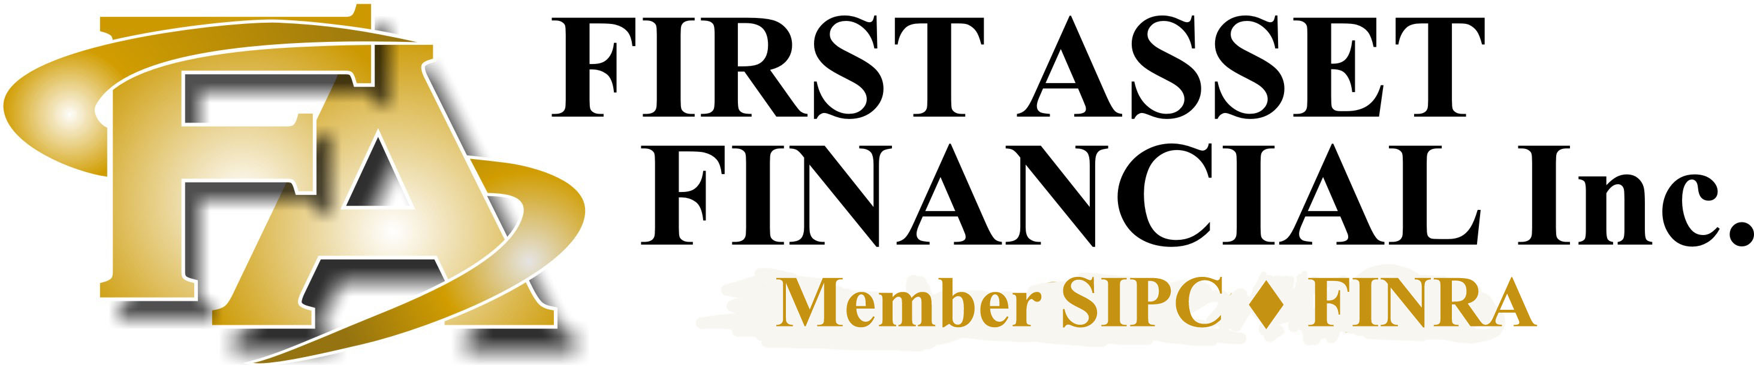

Please provide this to your financial institution for incoming wire instructions

AMOUNT TO BE WIRED:

JPMorgan Chase Bank, N.A.

601 Travis St., 18th Floor, TX2-C095

Huston, TX 77002

ABA # 021000021

Southwest Securities, Inc.

Dallas TX

Account # 08805076955

For further credit to:
( Customer’s Name at First Asset Financial )

Account Number:
( Customer’s Account Number at SWS )

Attention: Kay Bell
( Cashier’s name or person at SWS )

